Que:-1 What is software? What Software engineering?

🡪Software refers to a collection of programs, data, and instructions that tell a computer or other electronic devices how to perform specific tasks.``

🡪 Software is call set of program.

🡪 Software is Part of computer.

🡪 Can not Touch Software.

Software engineering:-

🡪Software engineering is the discipline of designing, developing, testing, and maintaining software systems.

🡪Software engineering is the process of creating and maintaining software programs in a structured and systematic way.

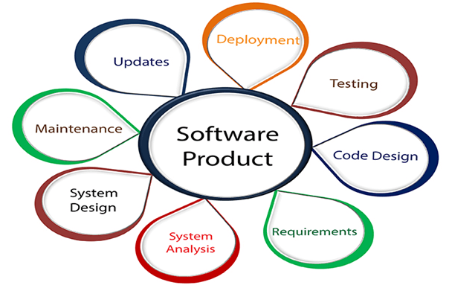

**Que:-2 Explain type of Software**?

**1 System software**

* **Operating** Systems: Manage computer hardware and provide a platform for running other software
* (e.g., Windows, macOS, Linux).

**2 Application software**

* Media Software: Used for creating, editing, and viewing media files (e.g., Adobe Photoshop, VLC Media Player).
* Web Browsers: Access and navigate the internet (e.g., Chrome, Firefox, Safari).
* Productivity Software: Helps with tasks like creating documents, spreadsheets, and presentations (e.g., Microsoft Office, Google Workspace).

3 **Development Software**:

* Integrated Development Environments : Tools for writing and testing code (e.g., Visual Studio, Eclipse).
* **Compilers and Interpreters**: Convert code into executable programs (e.g., GCC, Python interpreter).

**4 Database Software:**

* Database Management Systems (DBMS): Manage and organize data (e.g., MySQL, Oracle, Microsoft SQL Server).

**5 Embedded Software**:

* Firmware: Specialized software programmed into hardware devices (e.g., firmware in routers, embedded systems in cars).

**Que:-3 What is S D L C? explain each phace of S d l c?**

* The Software Development Life Cycle (SDLC) refers to a methodology with clearly defined processes for creating high-quality software
* SDLC Cycle represents the process of developing software. SDLC framework includes the following steps:-
* 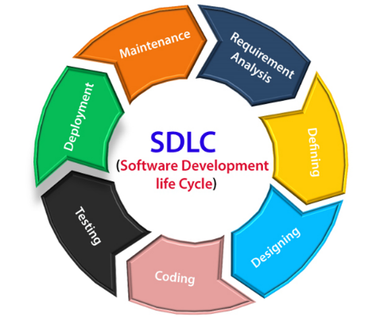

1. Requirement Gathering

2. Analysis

3. Designing

4. Implementation

5. Testing

6. Maintenanc

* The stages of SDLC are as follows:

**1: Planning and requirement analysis**

* Requirement Analysis is the most important and necessary stage in SDLC.
* Planning for the quality assurance requirements and identifications of the risks associated with the projects is also done at this stage
* .

### **. 2 Analysis :-**

* Once the planning is done, it’s time to switch to the research and analysis stage.
* This includes the first system prototype drafts, market research, and an evaluation of competitors.
* To successfully complete the analysis and put together all the critical information for a certain project, developers should do the follow.

**3 Design**:

* Plan the architecture and design of the software, focusing on how the system will work.
* This includes creating diagrams and models to visualize the software’s structure.

**4 Development**:

* Write the actual code according to the design. This is where the software is built by the developers.

**5 Testing**:

* Check the software for bugs, errors, or any issues. Testing ensures the software works as intended and meets the requirements.

**6 Maintenance**:

* Update and fix the software as needed after deployment. Maintenance ensures the software continues to function well over time.

Que 4:- what is DFD? Create DFD diagram on flipkart.

🡪DFD stands for Data Flow Diagram.

🡪 It's a graphical representation of the flow of data through a system, showing how data is processed, stored, and transmitted.

🡪DFDs are often used in software engineering, systems analysis, and business process modeling .

🡪We represent the flow of data graphically.

🡪Easily understand functionality.

External entity

Data flow

Process

Data store

Que 5 :- what is flow chart? Make addition of two number?

🡪 A flowchart is a visual representation of a process or system that shows the steps involved and the order in which they occur.

🡪It's a diagram that uses shapes, arrows, and text to illustrate the flow of information, decisions, and actions.

🡪Common symbols used in flowcharts include:

- Rectangles (or boxes) for steps or actions

- Diamonds for decisions or conditional statements

- Arrows to show the direction of flow

- Circles or ovals for start and end points

- Parallelograms for input/output operations

Input number1

Input number2

sum=number1+number2

Print(sum)

QUE-6 what is use case diagram? Create use case on bill payment on paytm.

🡪A Use Case Diagram is a visual representation of the interactions between a system and its users, showing how users achieve their goals through the system.

🡪Use case diagrams are particularly useful in the early stages of system design to capture the system's functional requirements and to communicate these to stakeholders.

🡪1. Actors (stick figures): Representing users or external systems that interact with the system.

2. Use Cases (ellipses): Representing the actions or goals that actors want to achieve through the system.

3. System Boundary (rectangle): Representing the system itself, which provides the functionality for the actors to achieve their goals

Actor

User

`